# Manual Test Plan

## 

1. link: <http://localhost:3000/> should be like

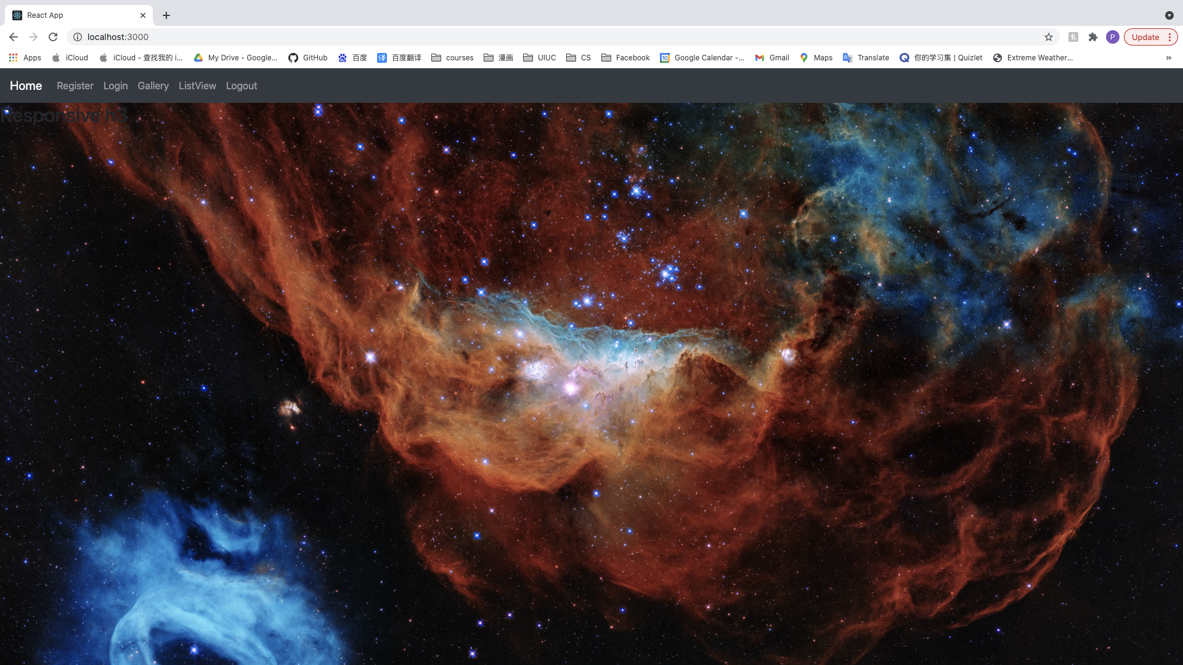

With an image from Nasa displaying

1. Click Register in navbar will redirect to

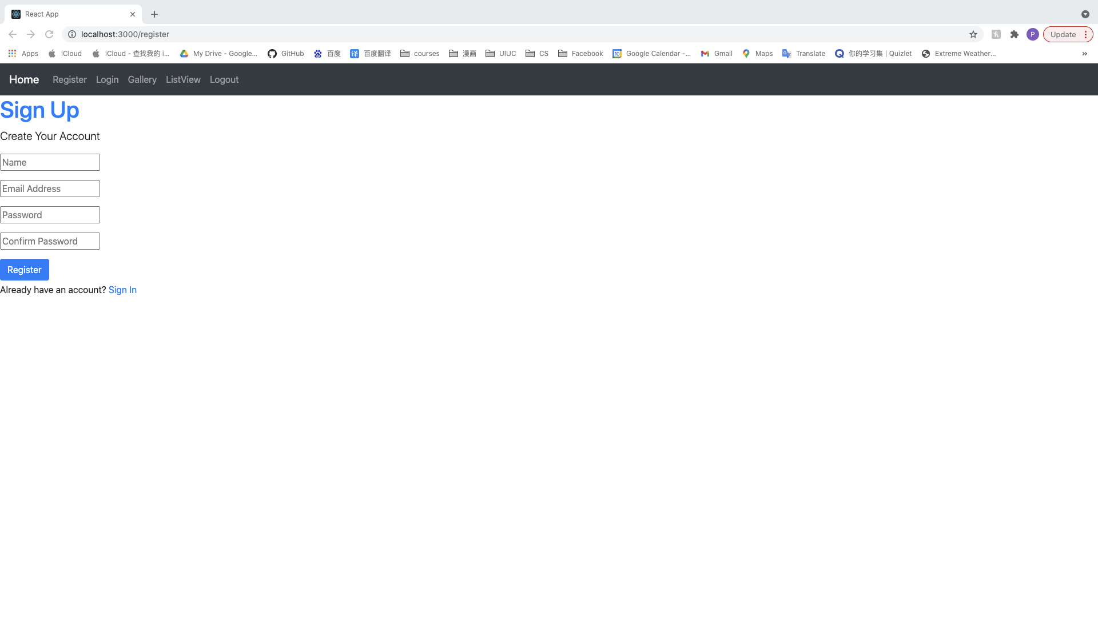

1. Click Sign in in register page will redirect to

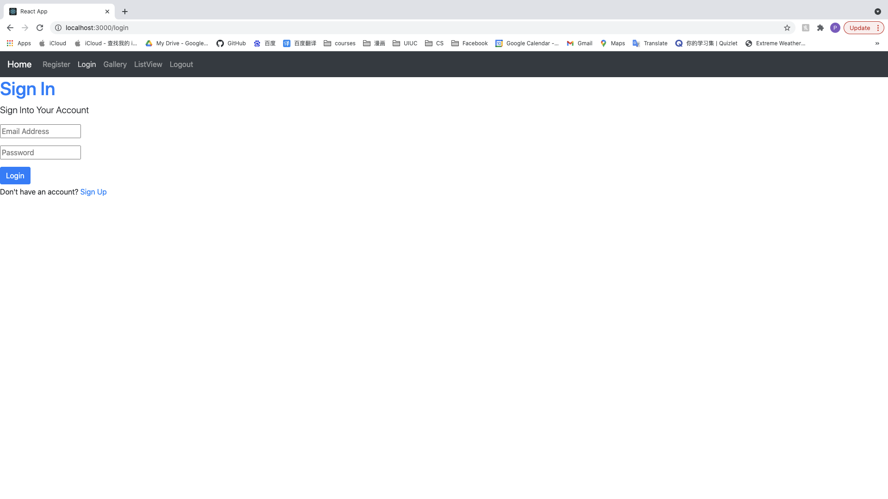

1. Click Login in navbar will redirect to



1. Click Sign up in Login page will redirect to

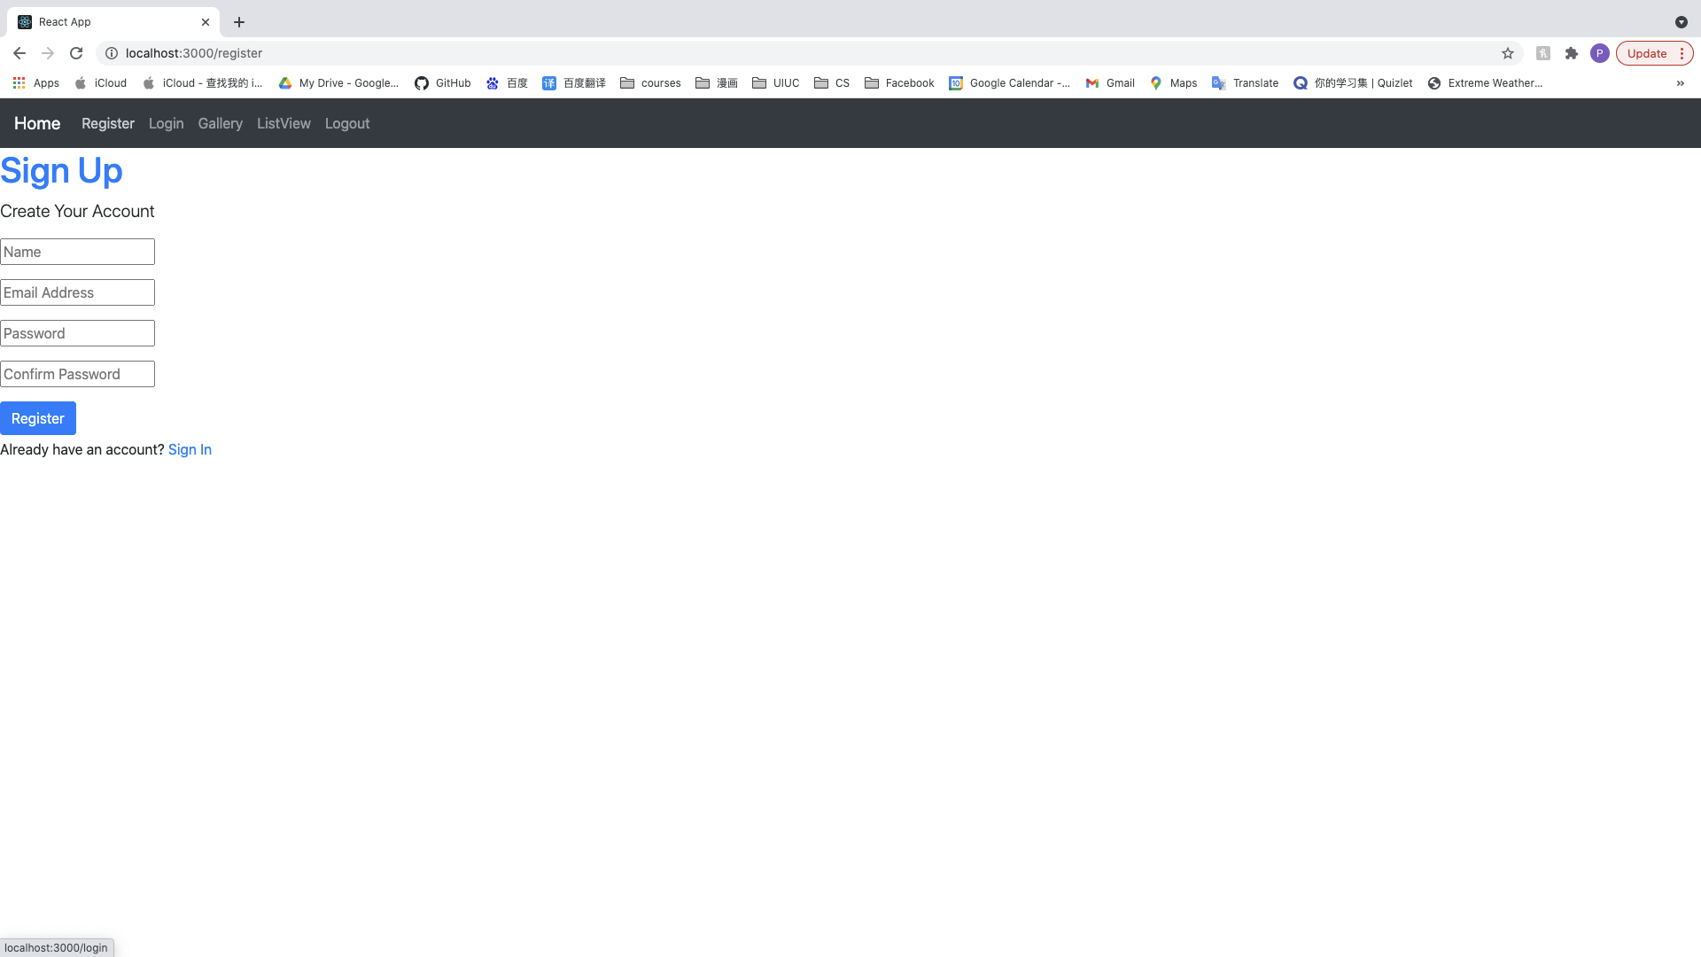

1. Without Name input, will be

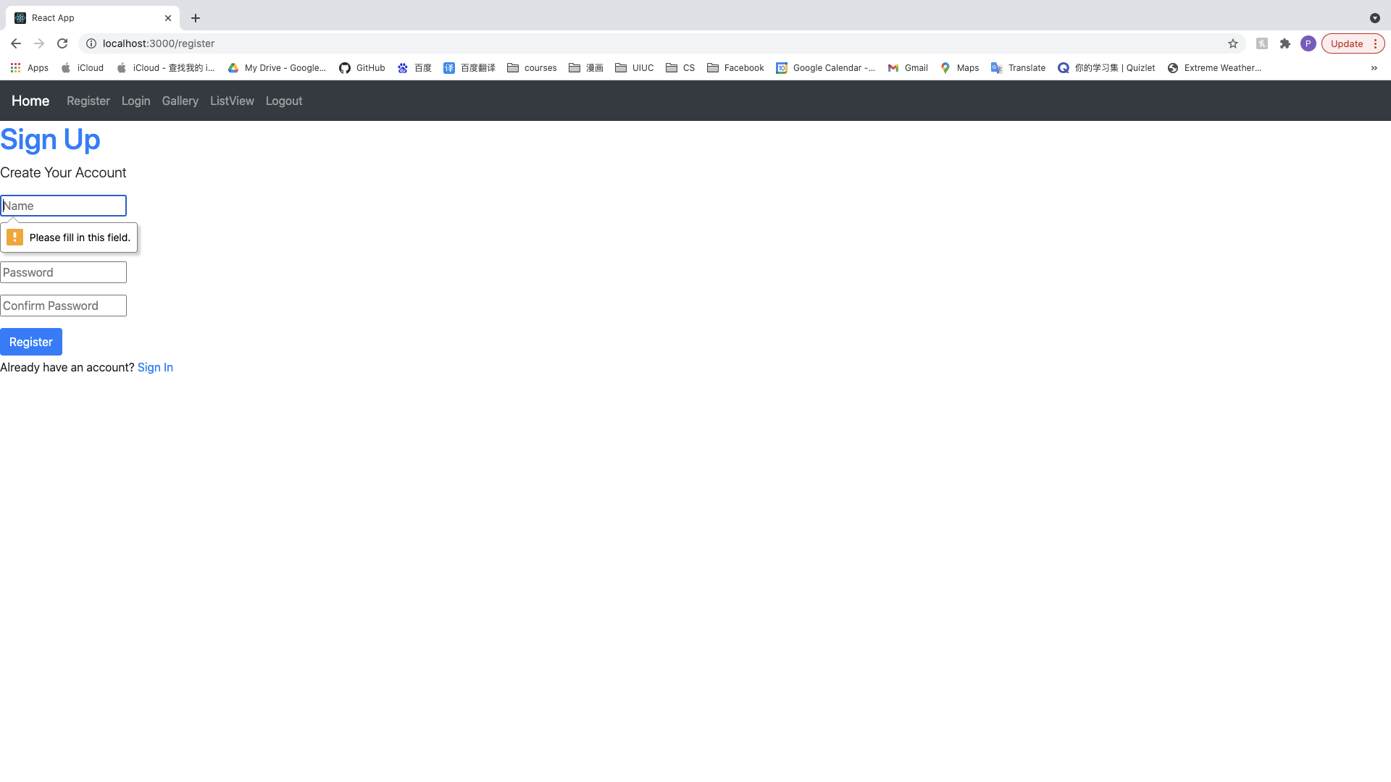

1. Without email address input

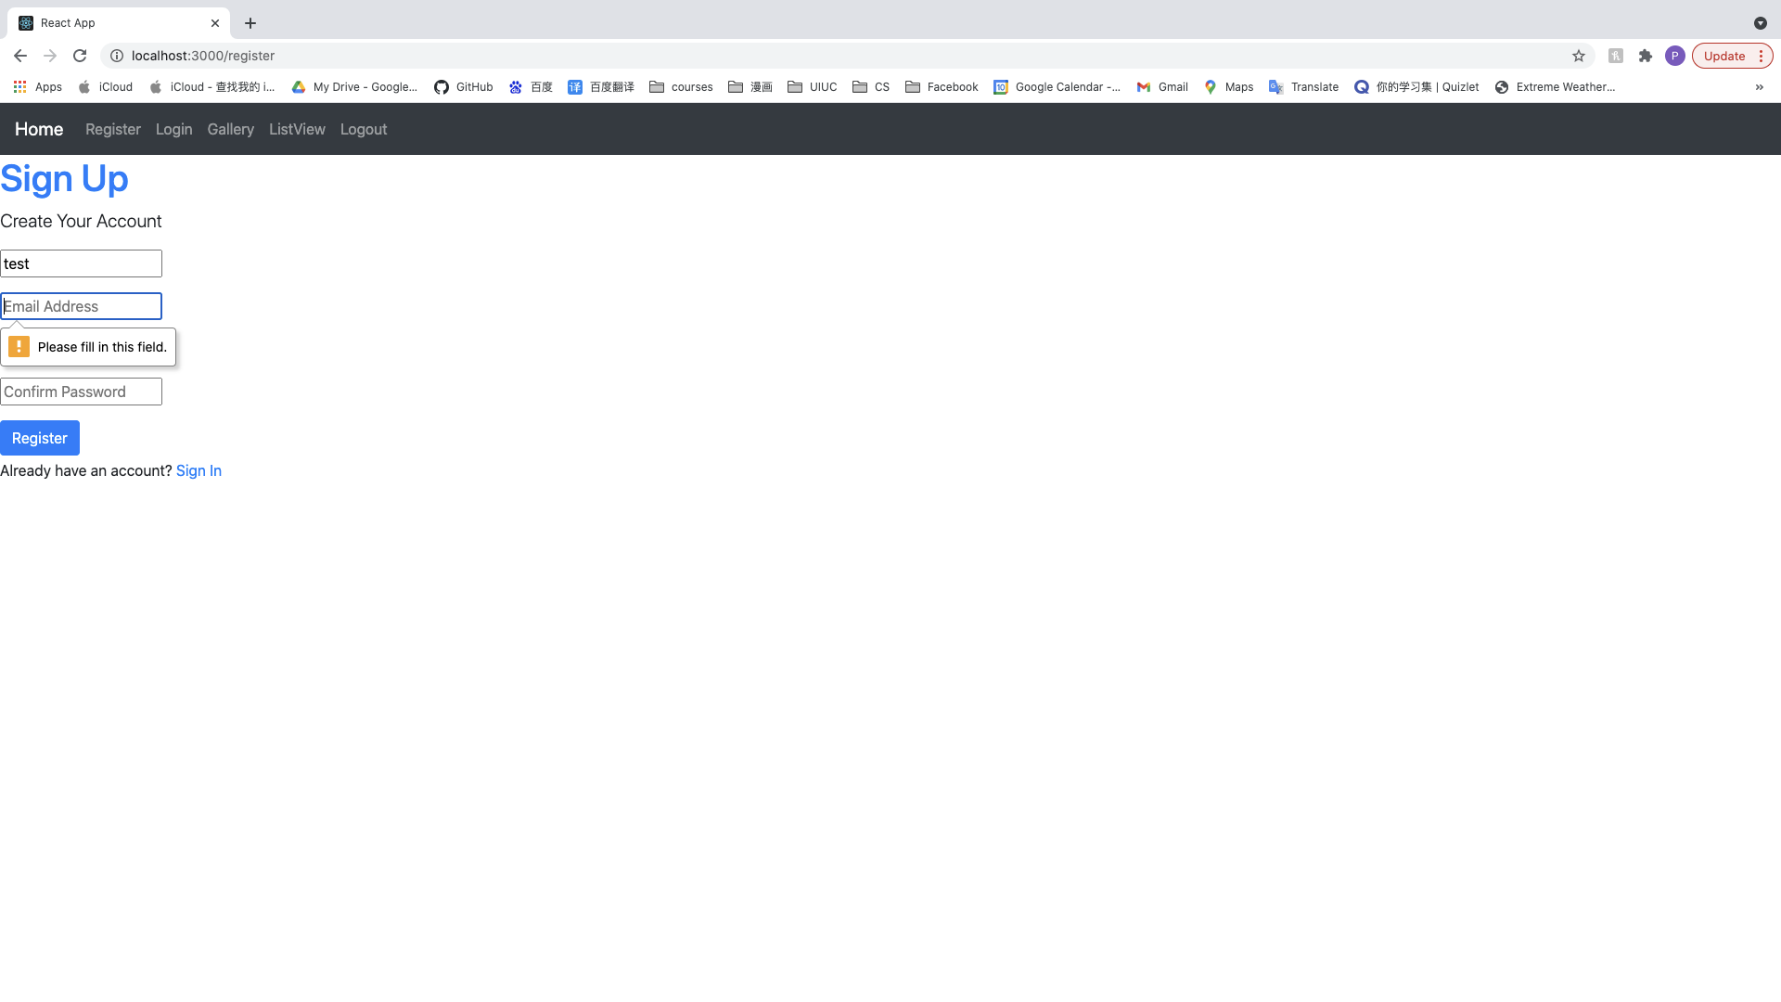

1. With an invalid email address input, will be

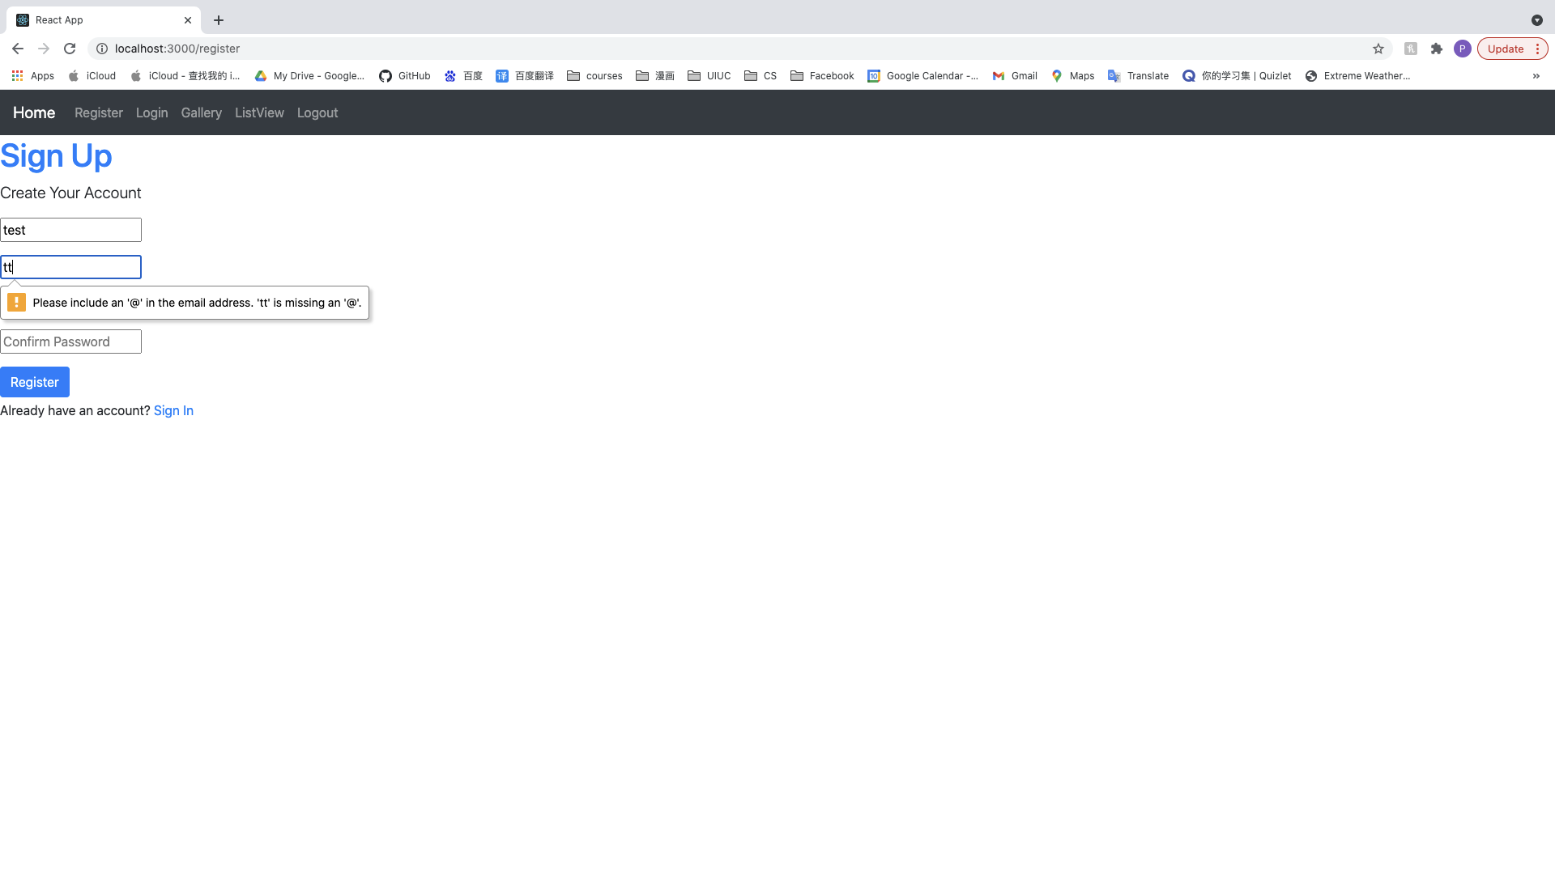

1. With a password length shorter than 6

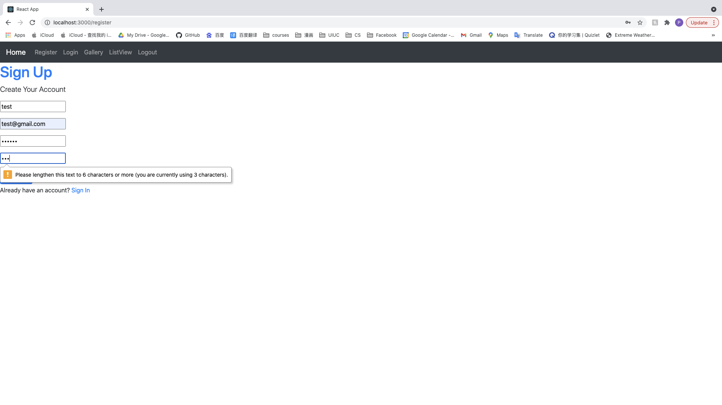

1. If sign up with two passwords doesn’t match

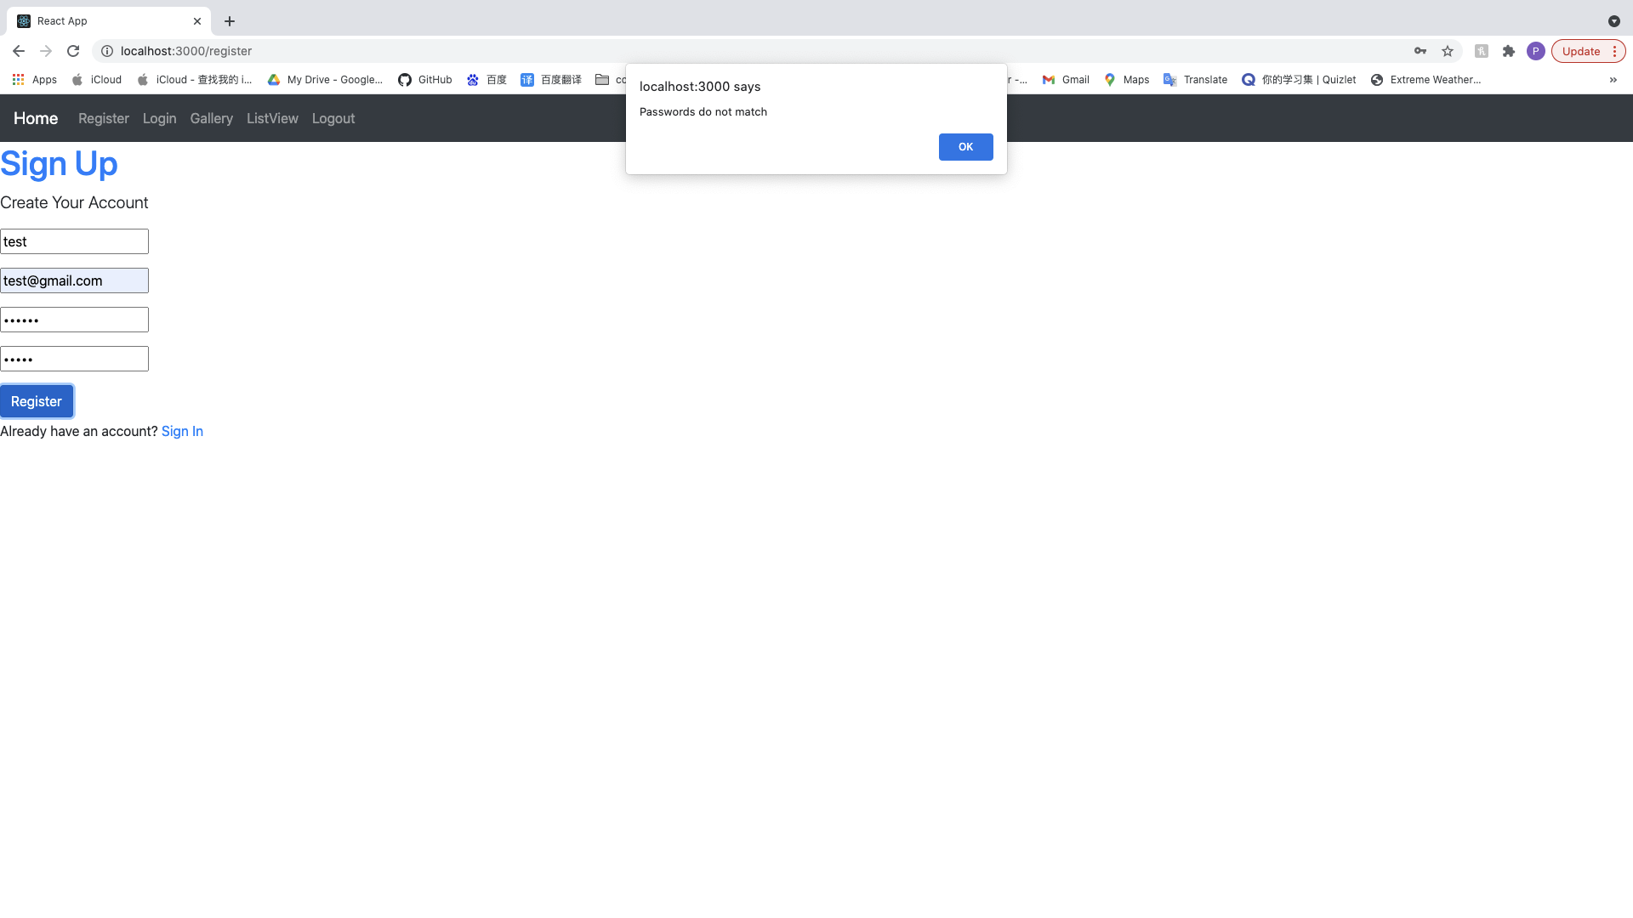

1. If the sign up user email has already existed

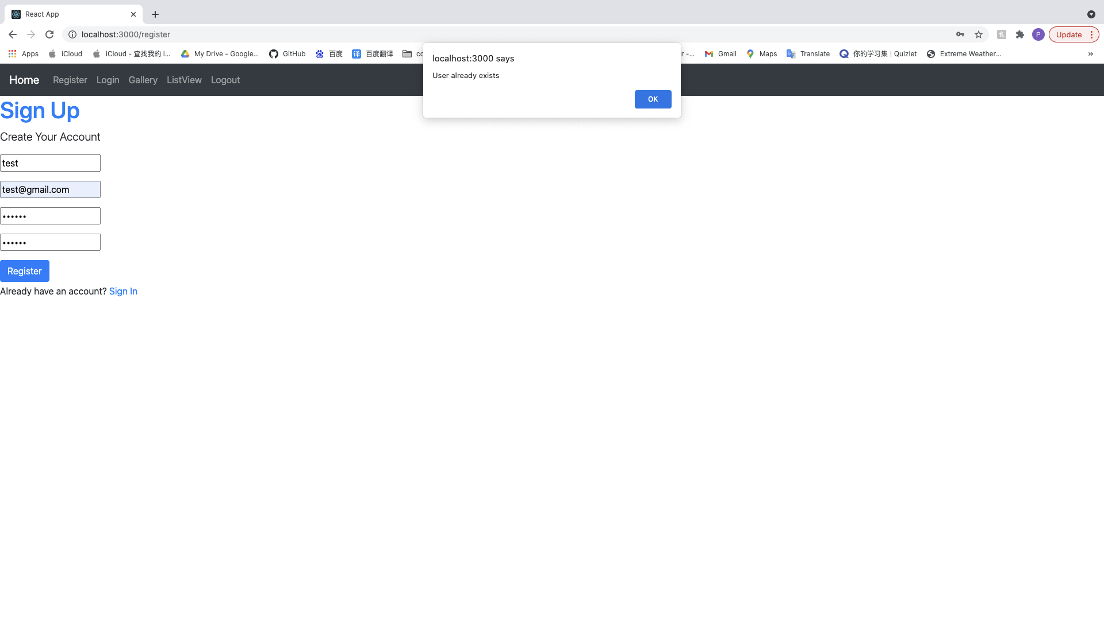

1. If sign up successfully

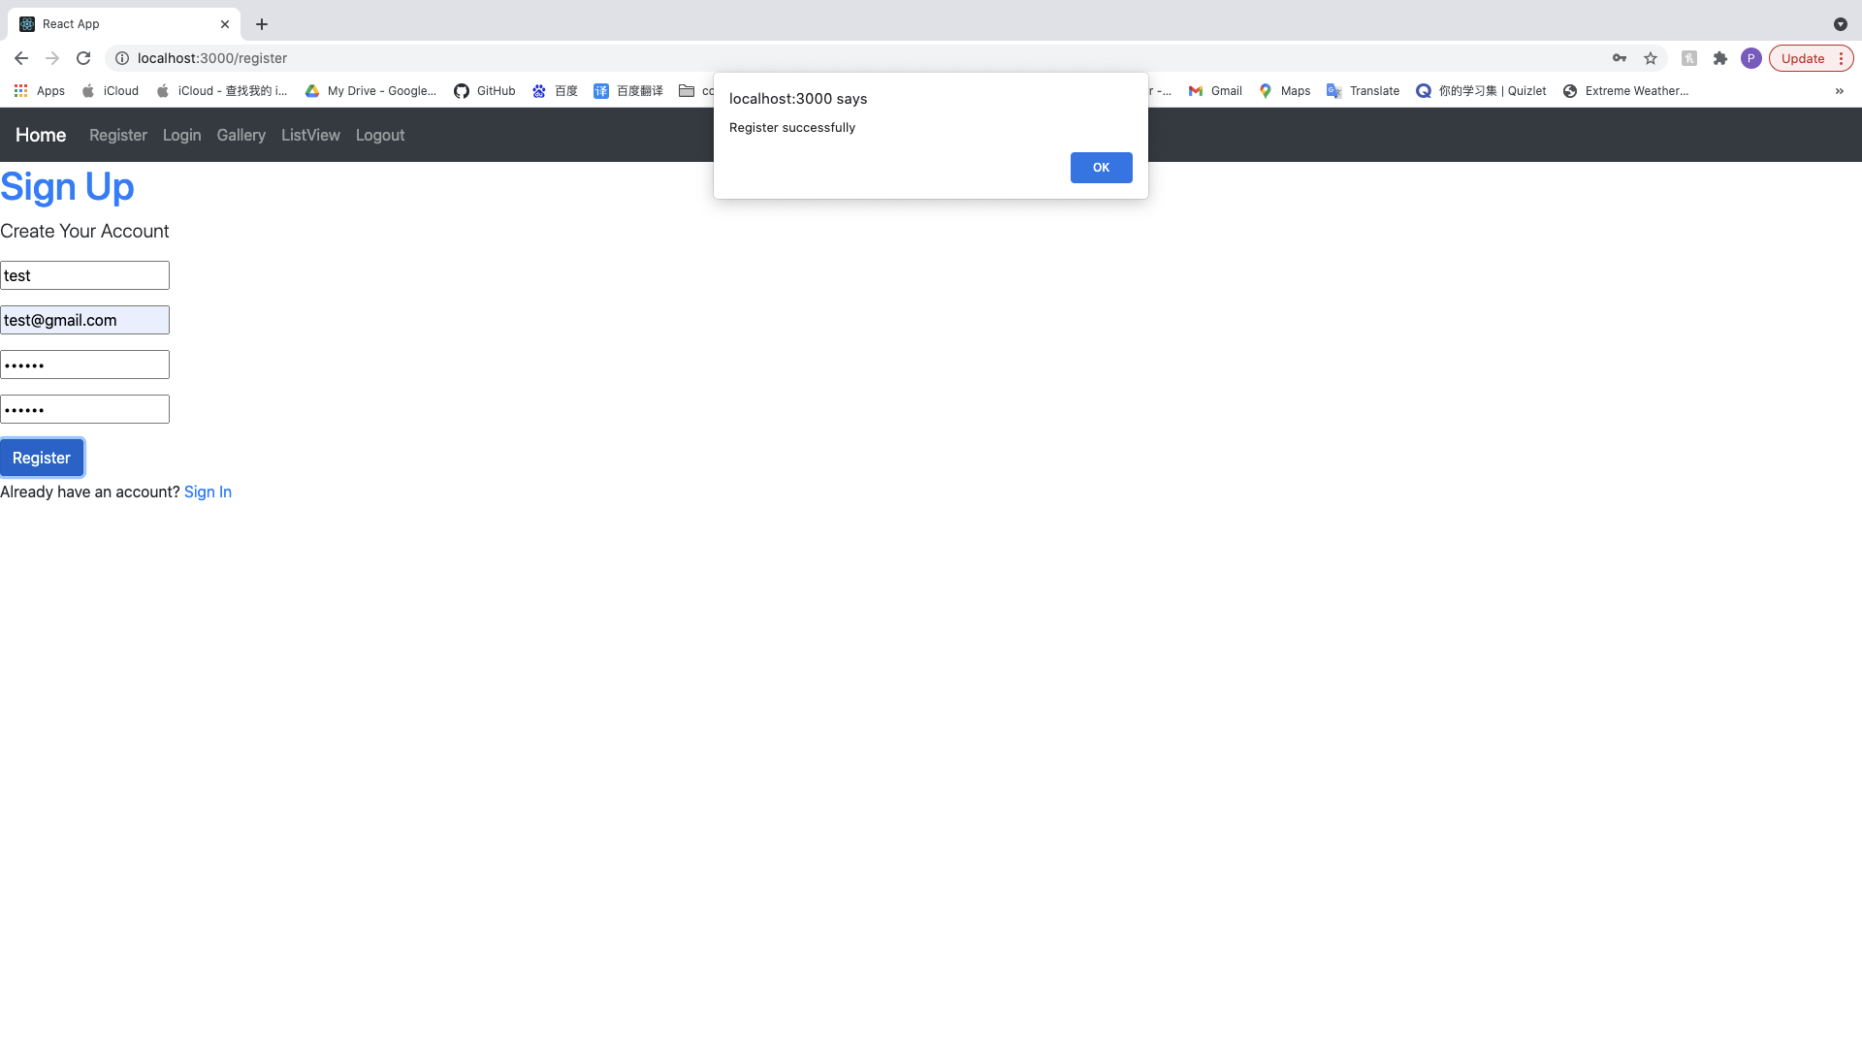

Clicking ok button will redirect the user to the home page

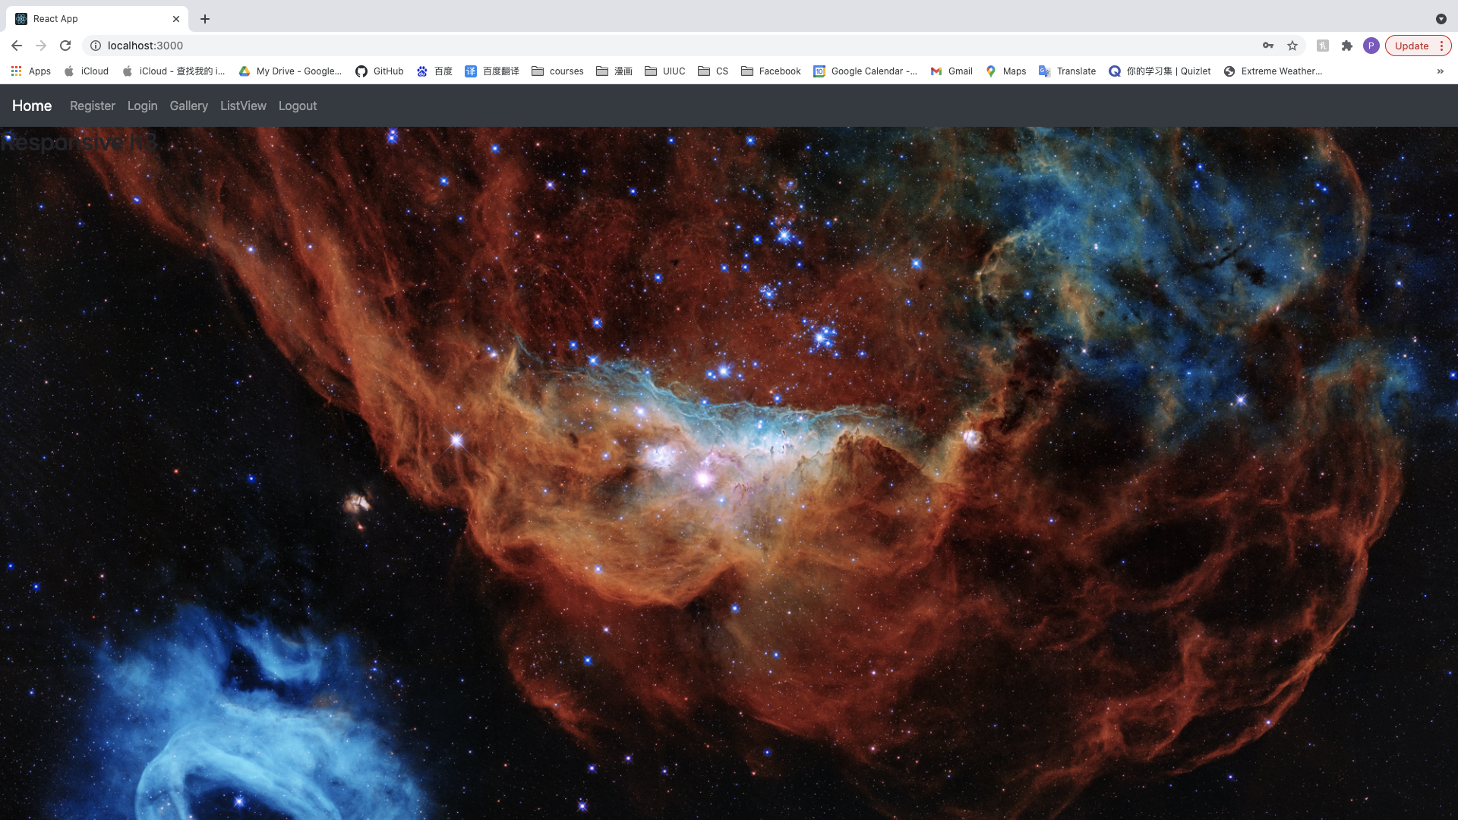

1. After successfully registered, the user has already automatically logged into the app; no response will have by clicking Register and Login in the navbar
2. Clicking Logout

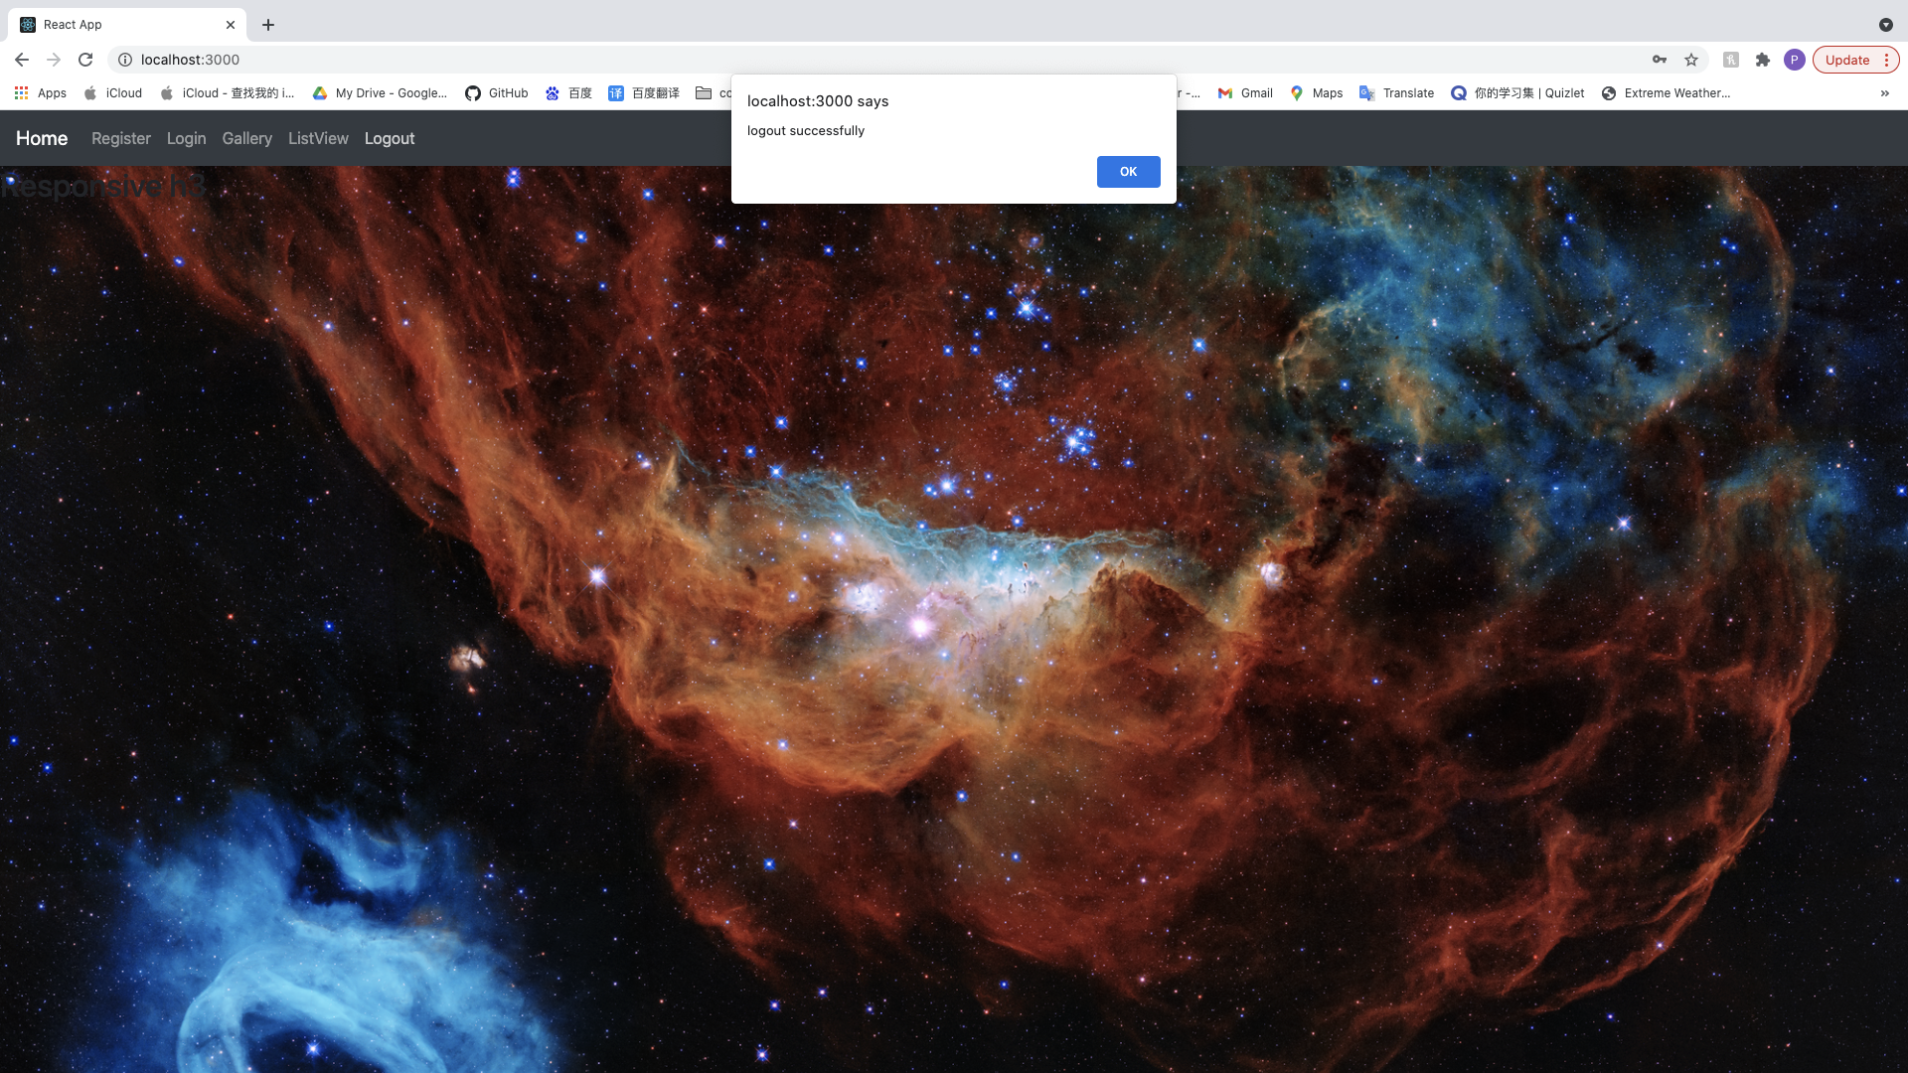

the user will be logged out from the app, then the user can clicking Register and Login again

1. Without email address input, will be

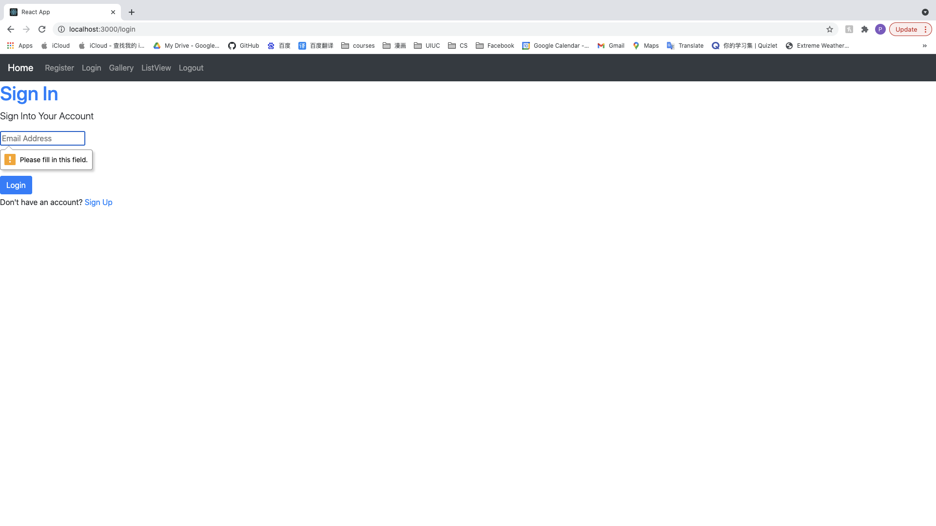

1. In sign In page, inputting password shorter than 6 characters will show

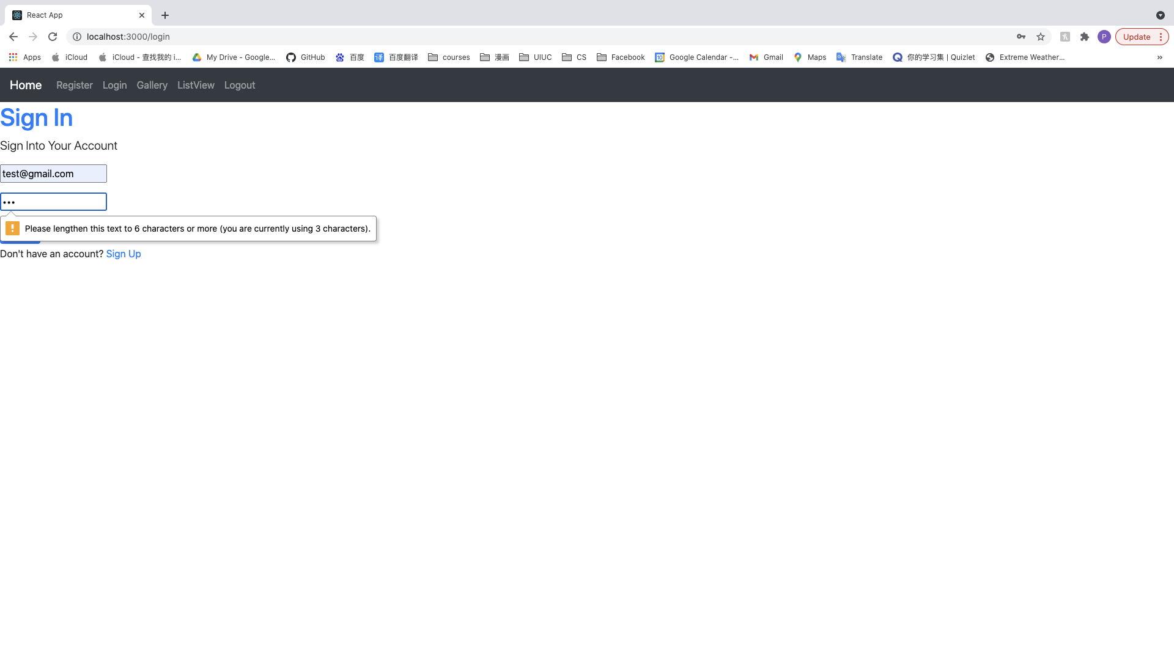

1. If the password isn’t correct, will be

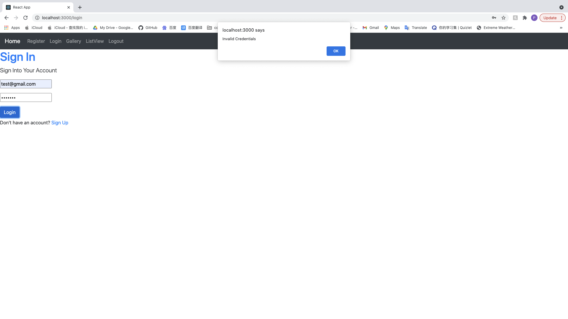

1. If the user doesn’t exist, will be

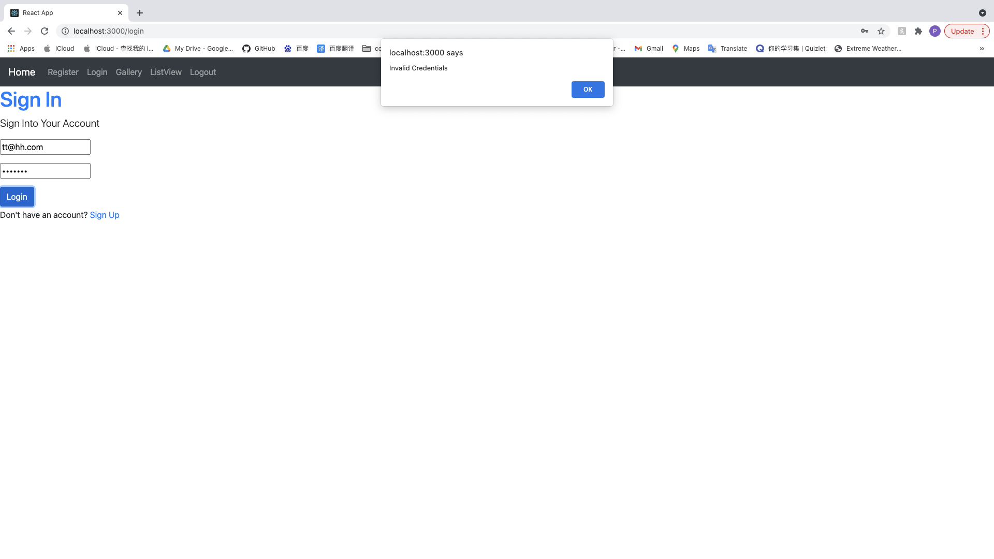

1. If the user doesn’t exist, will be

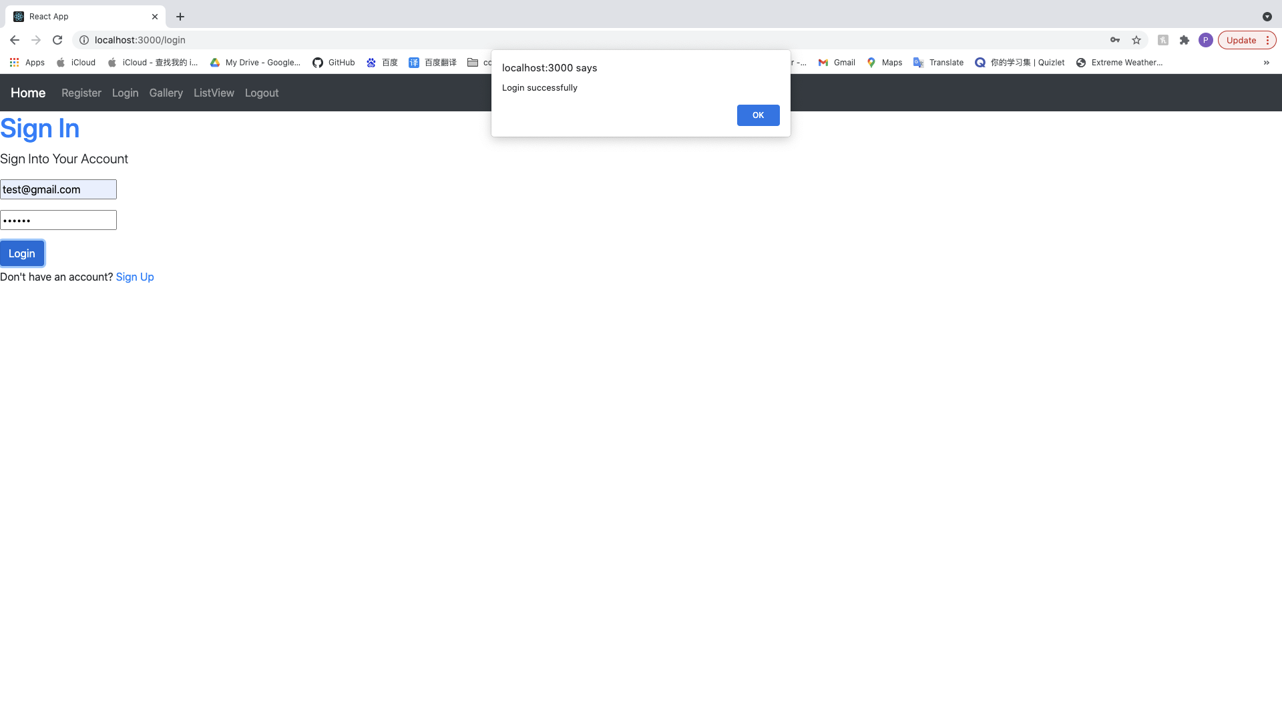

Clicking ok button will redirect the user to the home page



1. After successfully logged into the app, no response will have by clicking Register and Login in the navbar